

**CSE302: Database Systems (Section 01)**

**[FALL 2022]**

**Project Report**

**FIFA WORLD CUP 2022**

Project URL/Link

**Submitted by:**

|  |  |  |
| --- | --- | --- |
| **Student ID** | **Student Name** | **Contribution Percentage** |
| 2020-1-60-040 | Aisha Siddika Mim | **26** |
| 2020-1-60-156 | Munem Shahriar | **30** |
| 2020-1-60-151 | Tamanna - E- Jahan | **20** |
| 2019-3-60-051 | Md Anikur Rahaman | **24** |

# Final version of the E-R Model of the Project

Insert the figure of the relational data model.

Mention assumptions if any.

You may change the orientation of this page if required (from portrait to landscape)

# Final Version of the Relational Data Model of the Project

Insert the figure of the relational data model.

Mention assumptions if any.

You may change the orientation of this page if required (from portrait to landscape)

# Implementation Checklist

|  |  |
| --- | --- |
| Description | Remarks |
| Project ID | 107368 |
| Workspace Name | fifa_group_1 |
| Workspace Email | shariaradip@gmail.com |
| Workspace Password | FIFAPROJECTGROUP1 |
|  |  |
| Authentication Type | Application Express/Custom (keep the relevant one) |
| Username and Password to Login |  |
| Munem Shahriar | 2020-1-60-156 |
| Aisha Siddika Mim | 2020-1-60-040 |
| Tamanna E Jahan | 2020-1-60-151 |
| Anik | 2019-3-60-051 |
| Manager | Manager |
| Guest | Guest |
| Uploaded and Displayed Images in Reports | yes |
| Implemented Page-wise Authorization | yes |
|  |  |
| Number of Reports with Forms | 12 |
| Number of Master-detail Forms | 1 |
| Number of Reports based on Queries, Aggregate Queries | 2 |
| Number of Parameterized Reports | 1 |
| Number of Graphs/Charts | 1 |
|  |  |
| Included any trigger/other feature which is not taught in class. If yes, please explain briefly. | Slider on home page, master-detail report, parameterized report |
| Write the most unique feature/functionality in your application or the page of your application that you are proud of. Explain briefly. |  |

# Reports with Forms

|  |  |  |
| --- | --- | --- |
| Report Page Number and Name | Form Page Number and Name | Table |
| write your report page number and name here | write your form page number and name here | write the name of the table for which pages are created |
| 02-Admin Report | 10-Admin Form | MY_USERS |
| 04-Coach Report | 05-Coach Form | COACH |
| 06-Player Report | 07-Player Form | PLAYER |
| 08-Referee Report | 09-Referee Form | REFEREE |
| 11-Match Report | 10-Match Form | MATCH |
| 14-Schedules | 15-Schedule Form | SCHEDULE |
| 16-Venues | 17-Venue Form | STADIUM |
| 18-Goals | 19-Goals Form | GOAL |
| 20-Match Statistics | 21-Match Statistics Form | MATCH_STATICTICS |
| 40-Country Flags | 41- Image Form | TEAM_IMAGE |
| 47-Team Report | 48-Team Form | TEAM |
| 84-Match Result | 85-Result Form | RESULT |

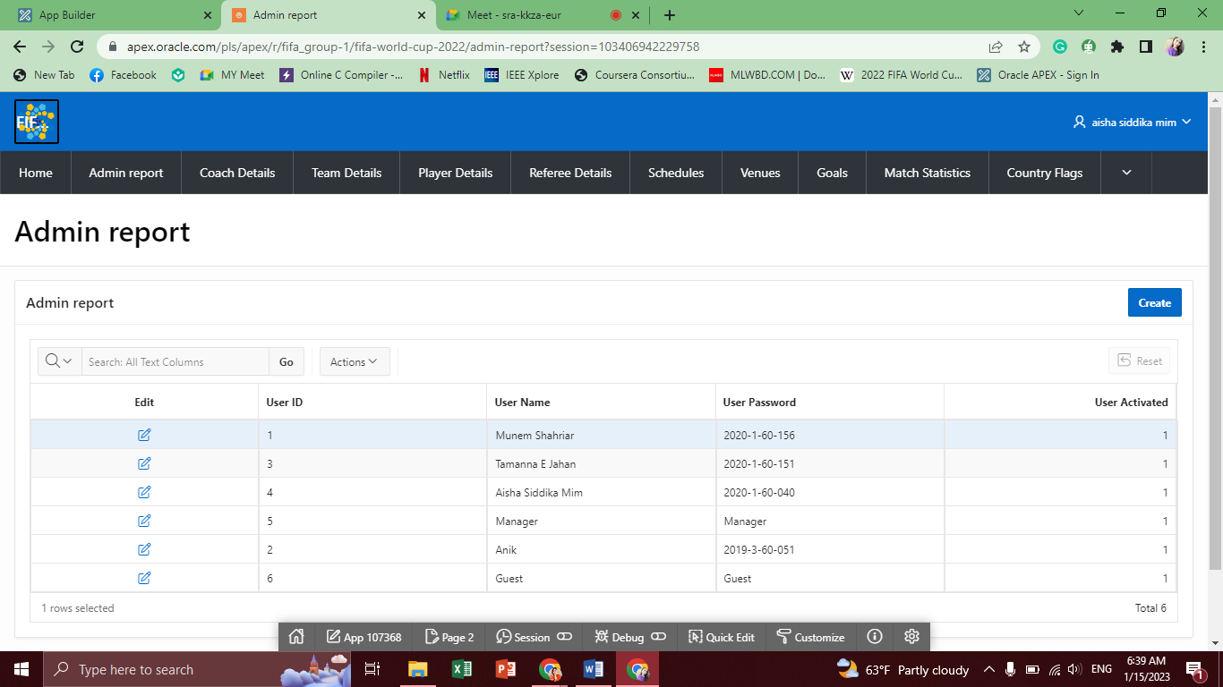

**1.1**

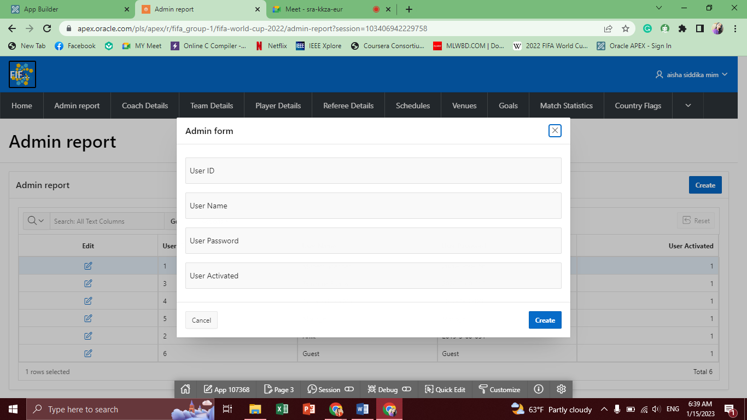

**1.2**

**Table: MY_USERS**

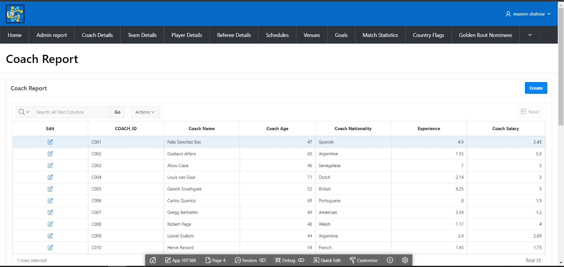

**2.1**

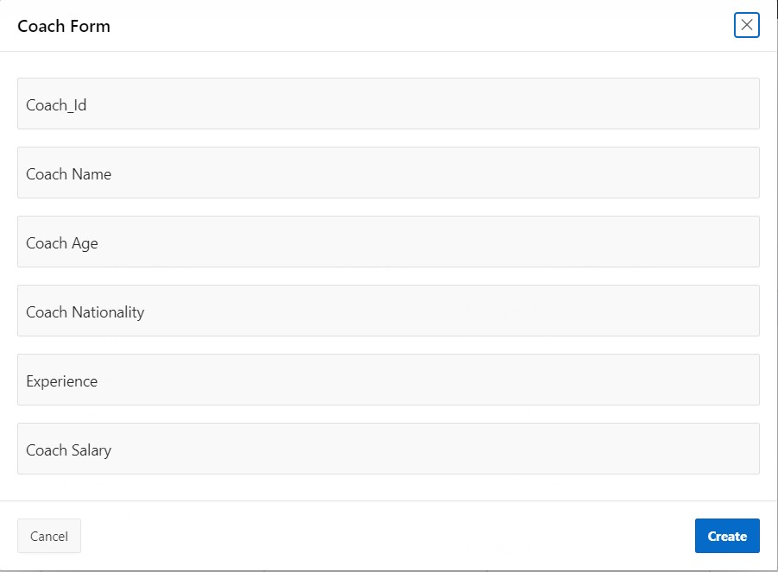

**2.2**

**Table: COACH**

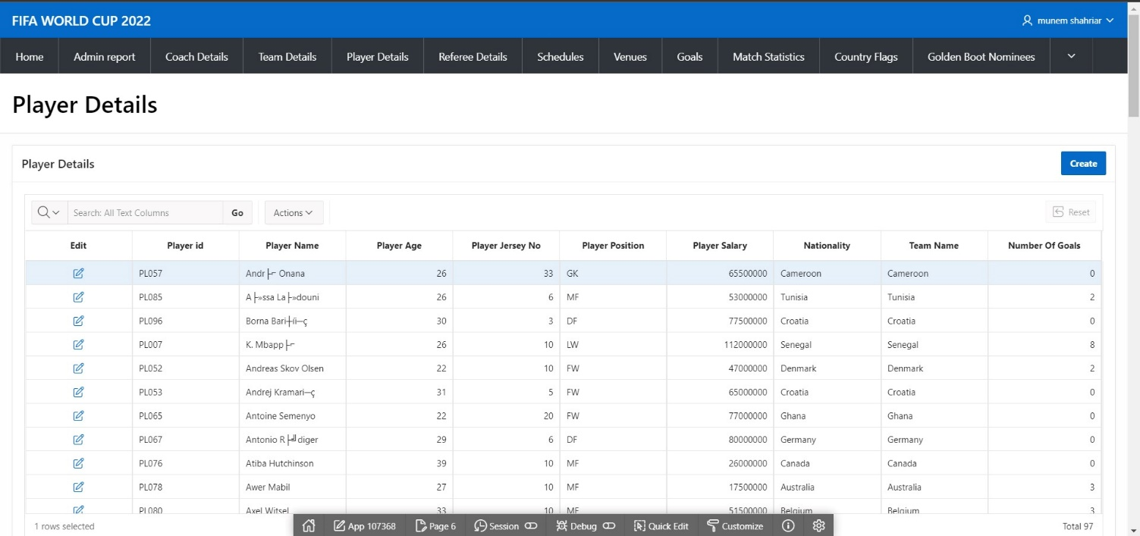

**3.1**

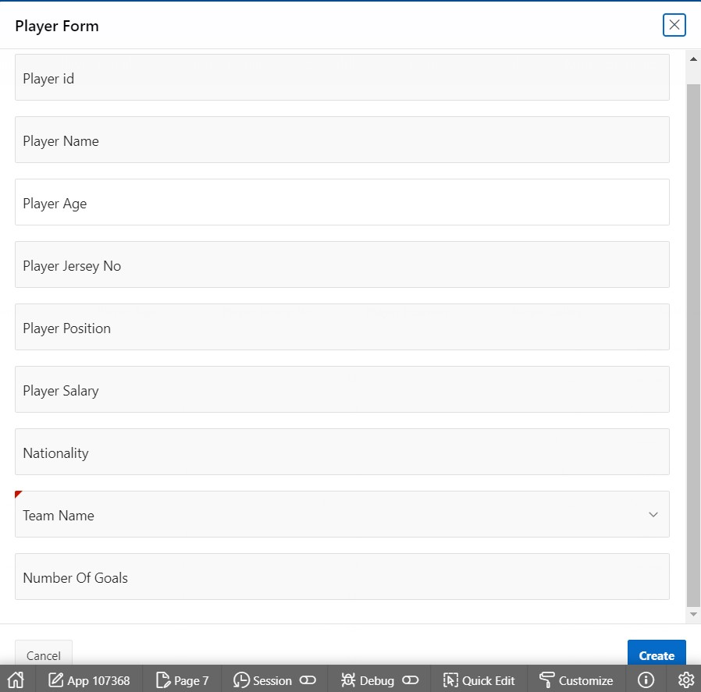

**3.2**

**Table: PLAYER**

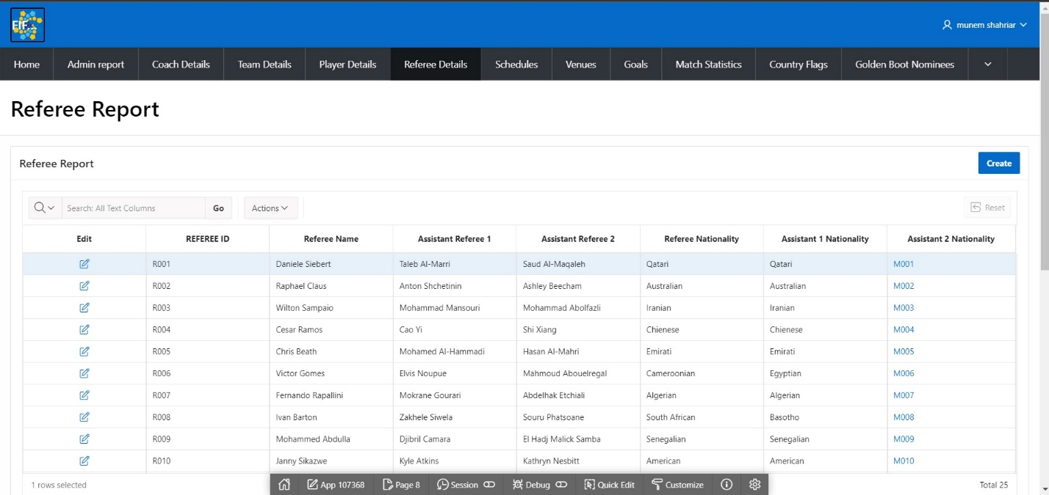

**4.1**

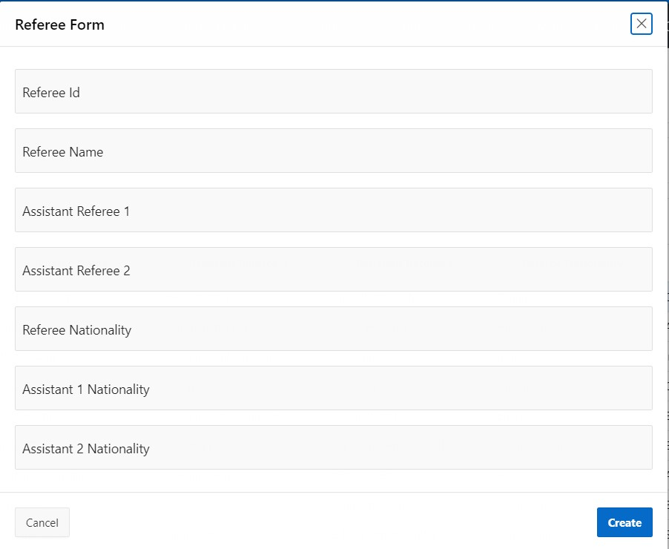

**4.2**

**Table: REFEREE**

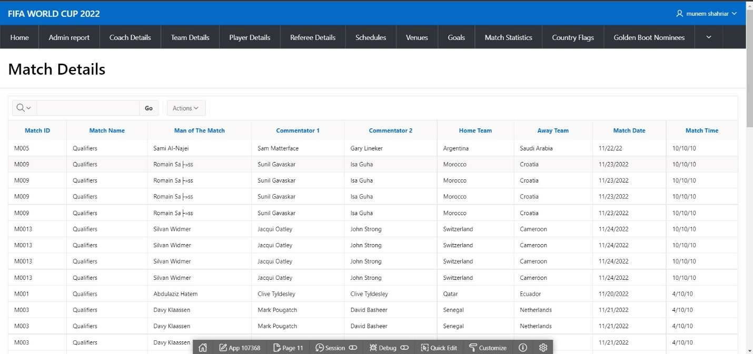

**5.1**

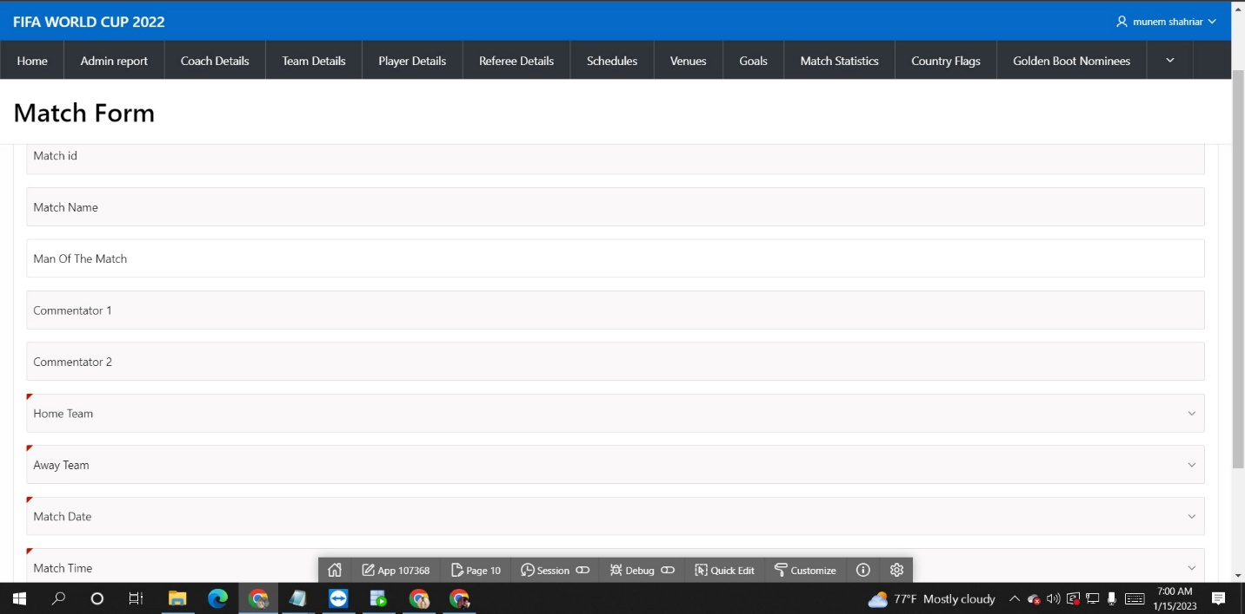

**5.2**

**Table: MATCH**

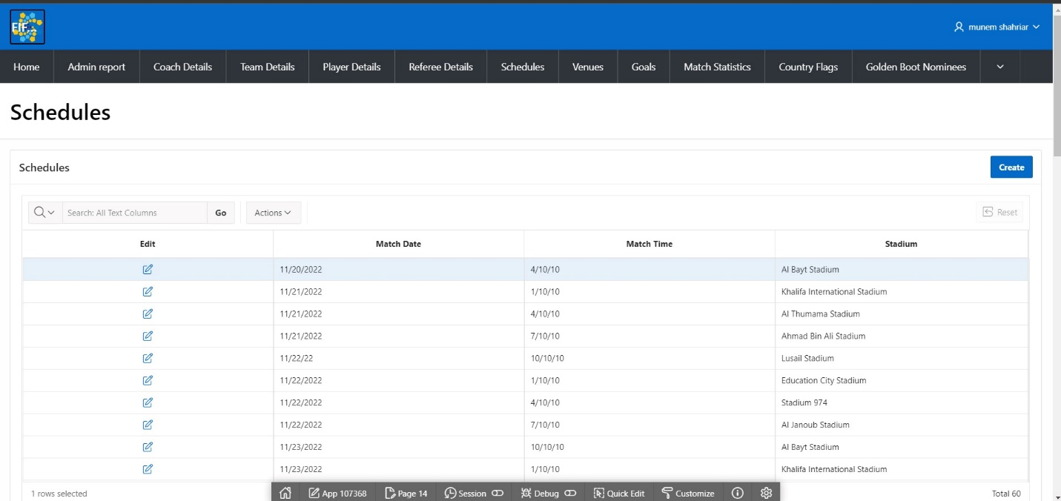

**6.1**

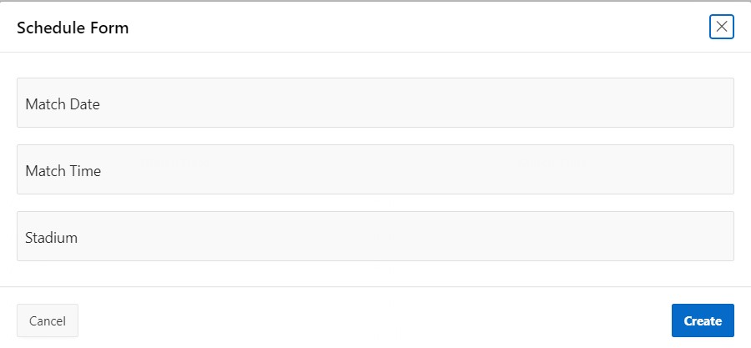

**6.2**

**Table: SCHEDULE**

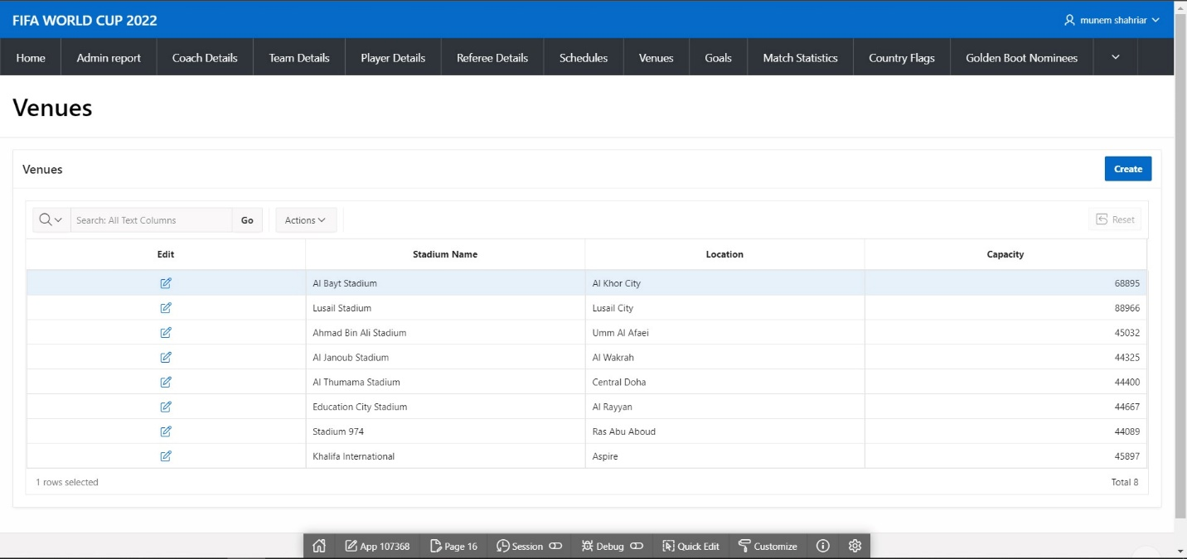

**7.1**

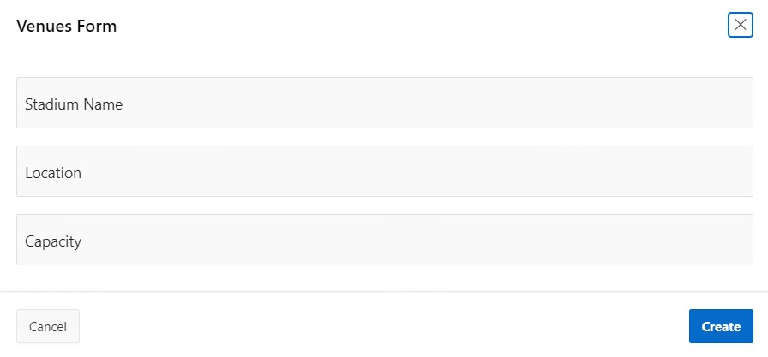

**7.2**

**Table: STADIUM**

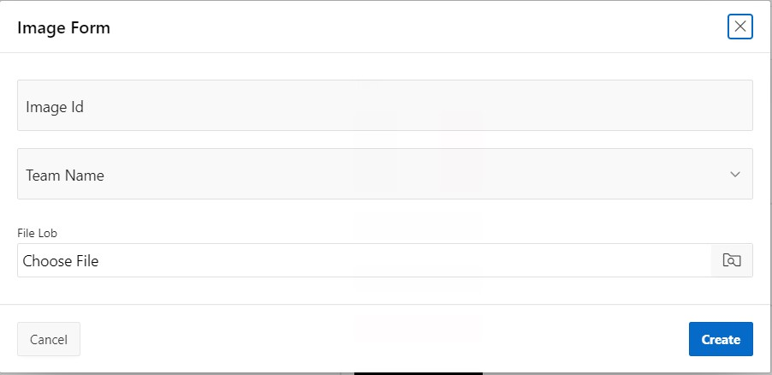

**8.1**

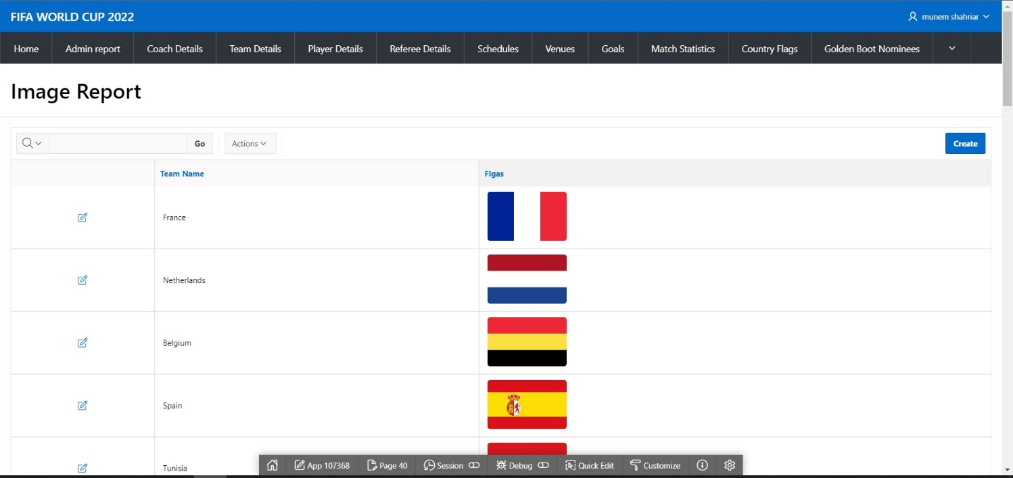

**8.2**

**Table:** TEAM_IMAGE 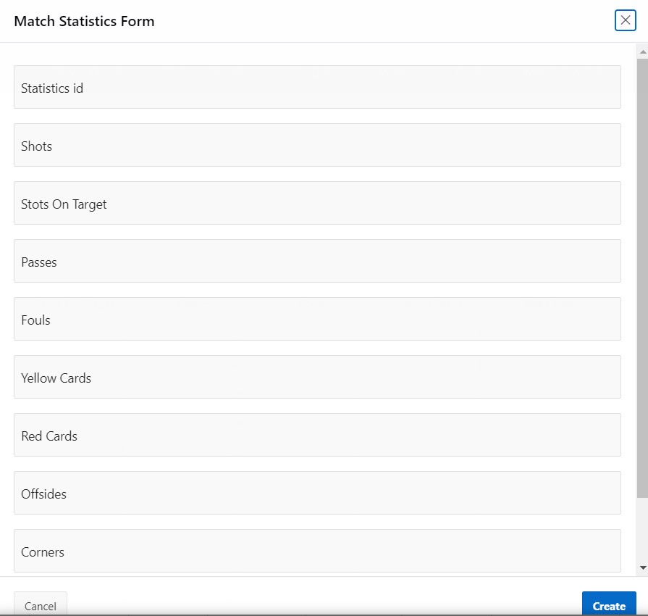

**9.1**

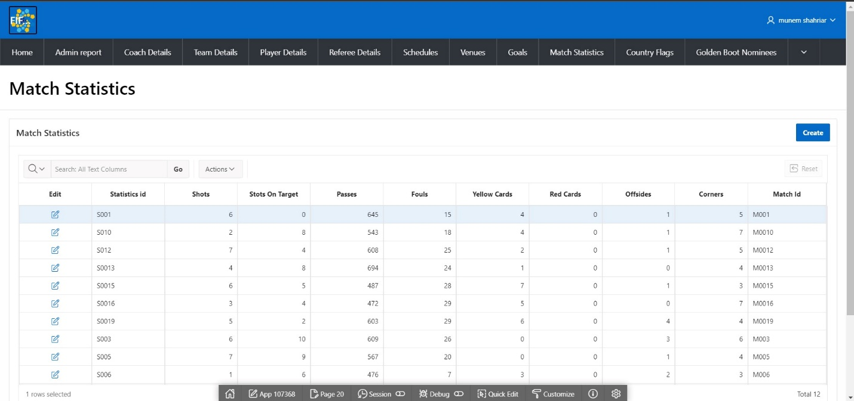

**9.2**

**Table:**

**MATCH_STATISTICS**

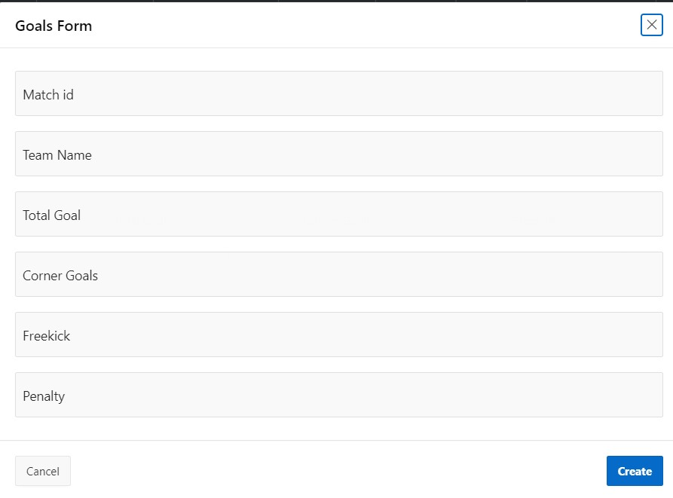

**10.1**

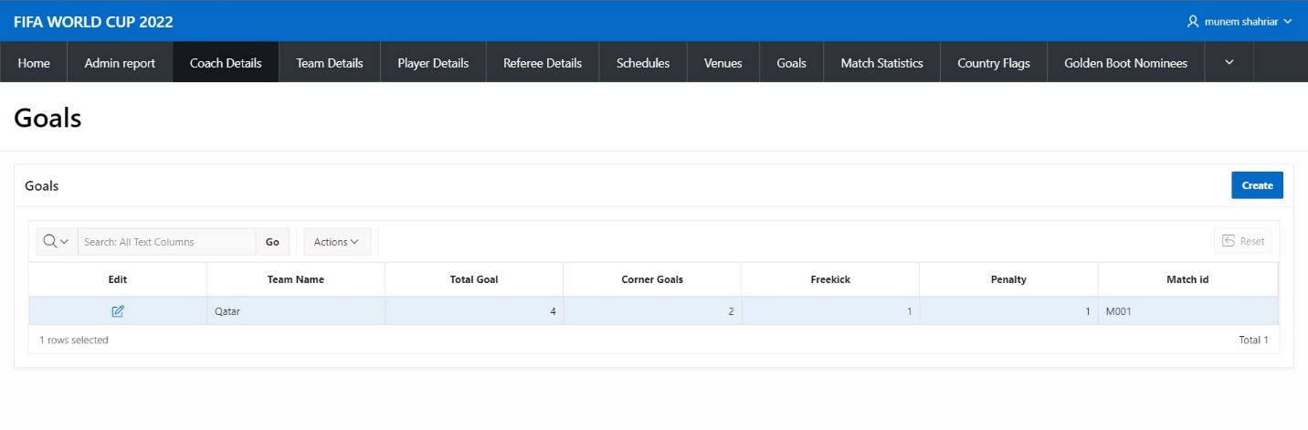

**10.2**

**Table: GOAL**

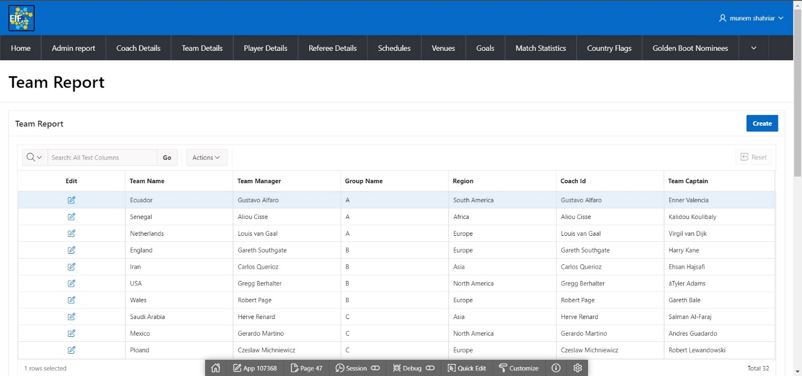

**11.1**

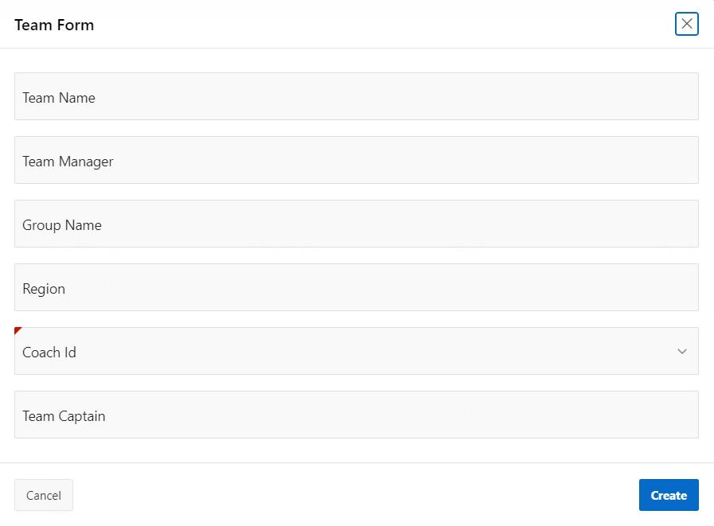

**11.2**

**Table: TEAM**

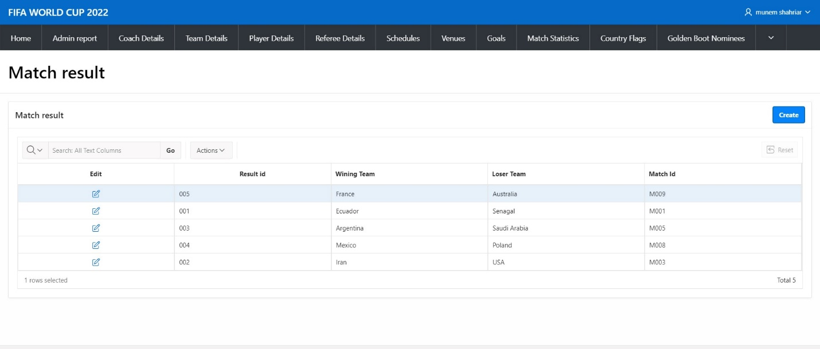

**12.1**

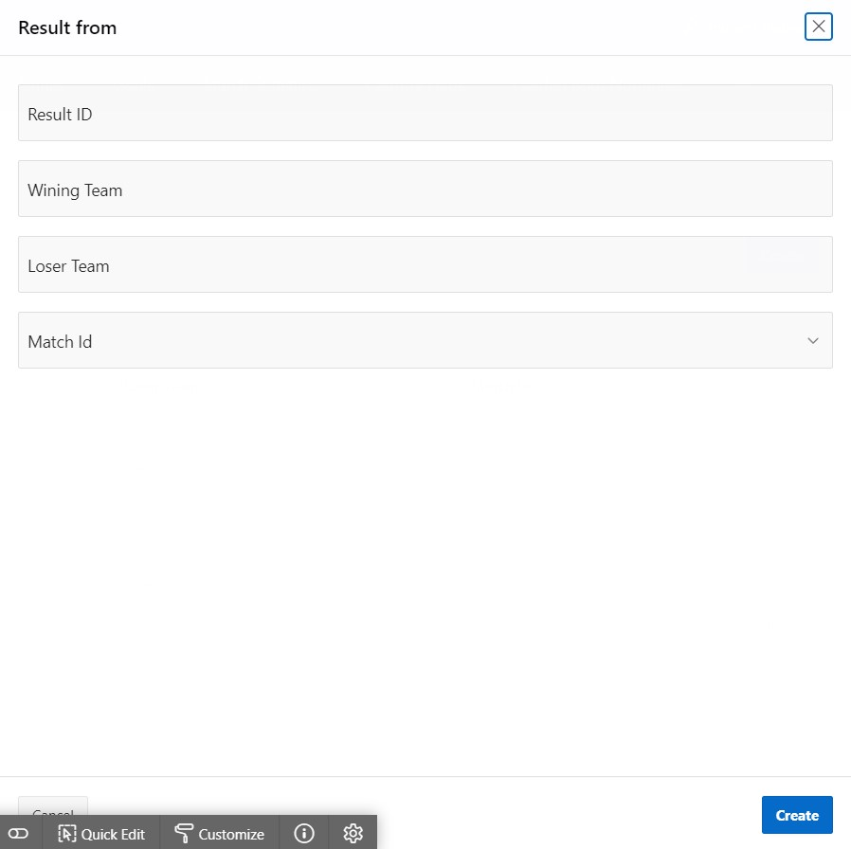

**12.2**

**Table: MATCH**

# Master-Detail Form

|  |  |  |
| --- | --- | --- |
| Page Number and Name | Master Table (Parent) | Detail Table (Child) |
| write your master-detail page number and name here | write the master table name here | write the detail table name here |
| 34-Master Detail | Team | Player |

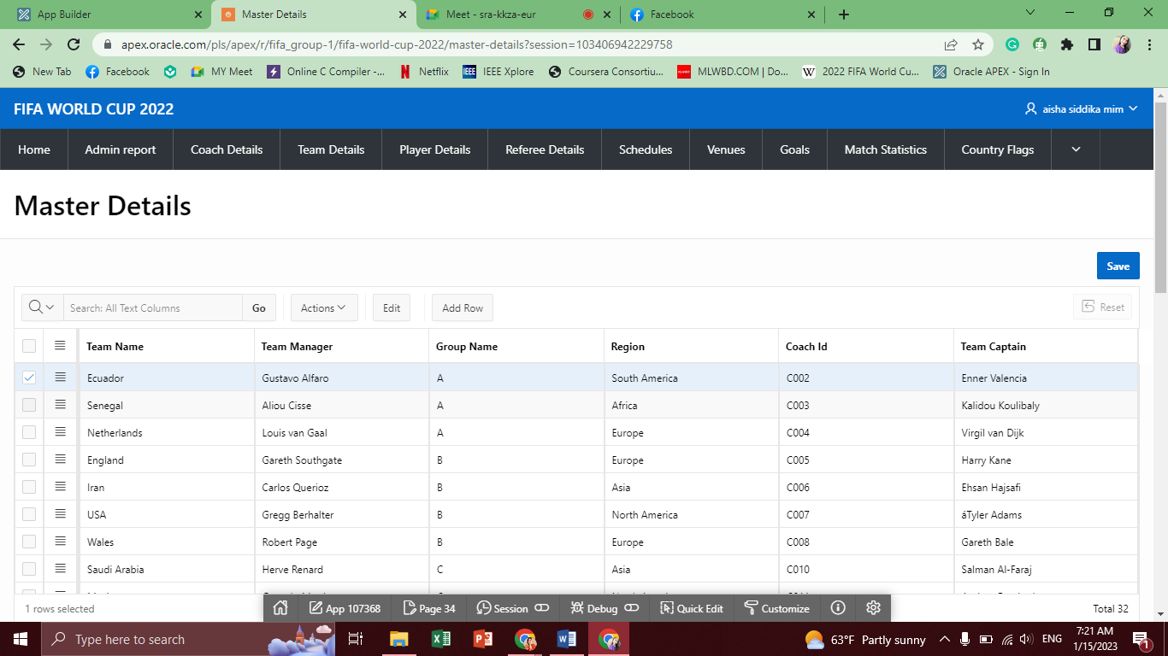

**13.1**

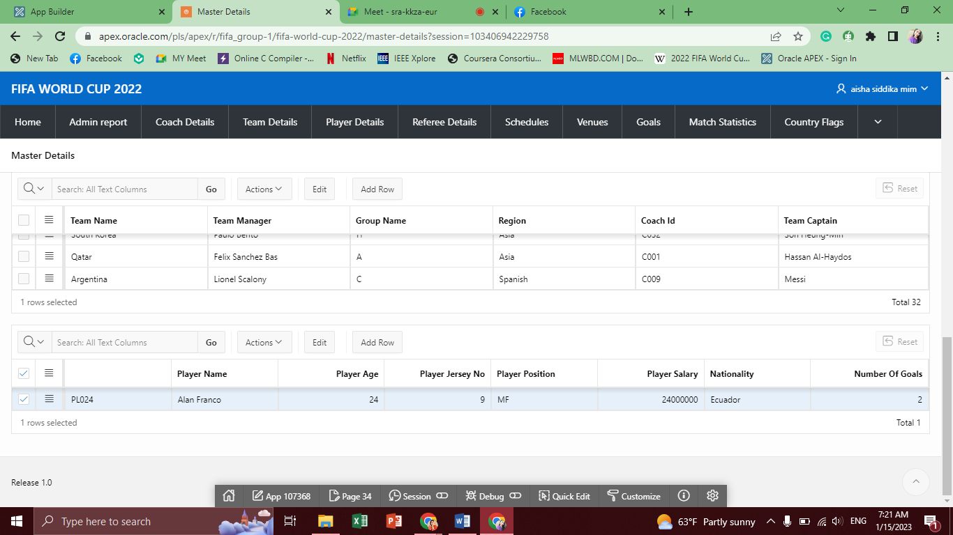

**13.2**

# Reports based on Multi-Table and Aggregate Queries

|  |  |  |
| --- | --- | --- |
| Page Number and Name | Query Type | Report description |
| write your report page number and name here | Multi-table/Aggregate | write the description of the report in a simple sentence such as this report shows the total number of instructors per department. |
| 46-Team Wise Total Goal | Aggregate | Total Goals for each team |
| 46-Highest Scorer | Aggregate | Highest goal scorer |

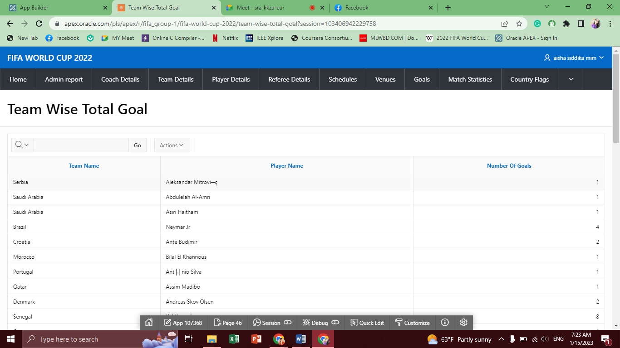

**14.1**

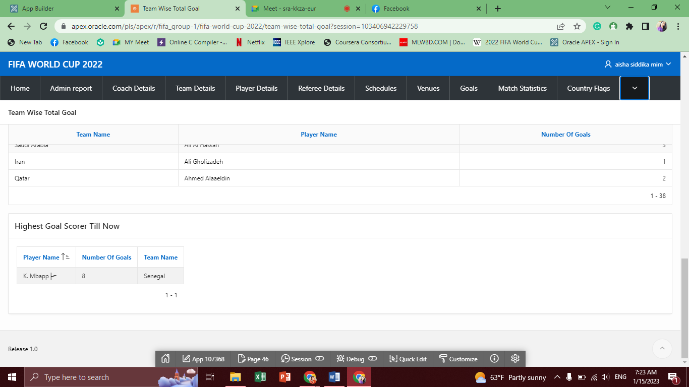

**14.2**

# Parameterized Reports

|  |  |  |
| --- | --- | --- |
| Page Number and Name | Given Input | Report description |
| write your page number and name here | write the name of the attribute which will be given by user | write the description of the report in a simple sentence such as this report shows the courses taught by the given instructor. |
| 74-Group | Group | By pressing group button, all team names are shown of that particular group |

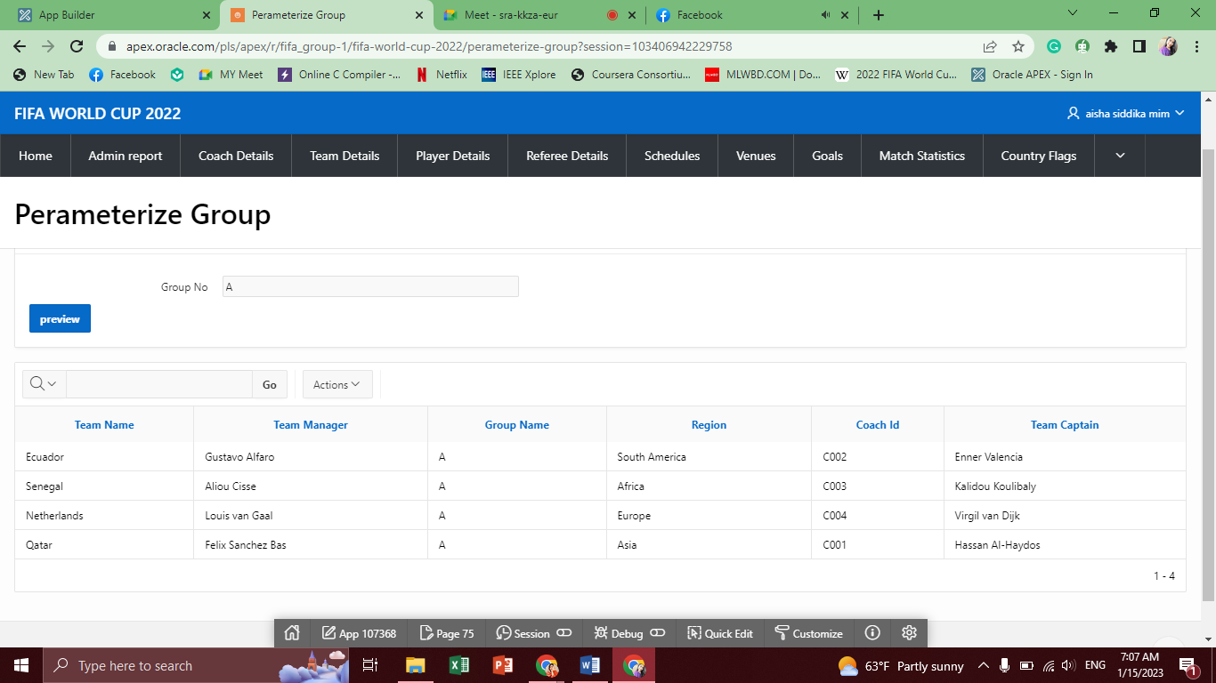

**15.1**

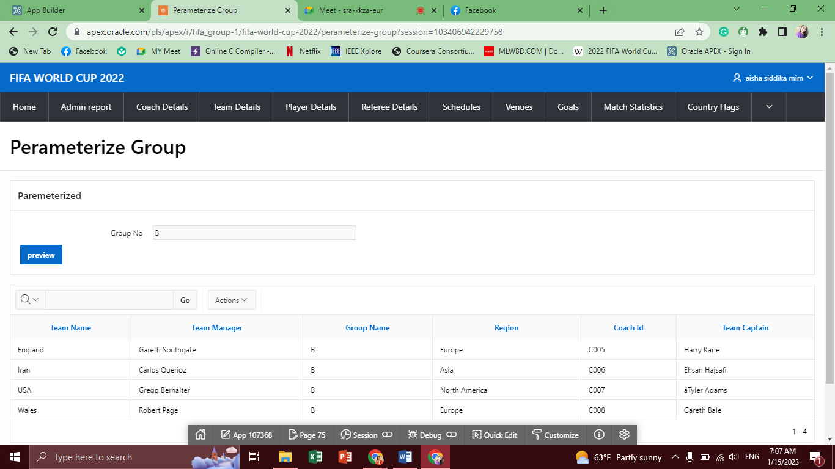

**15.2**

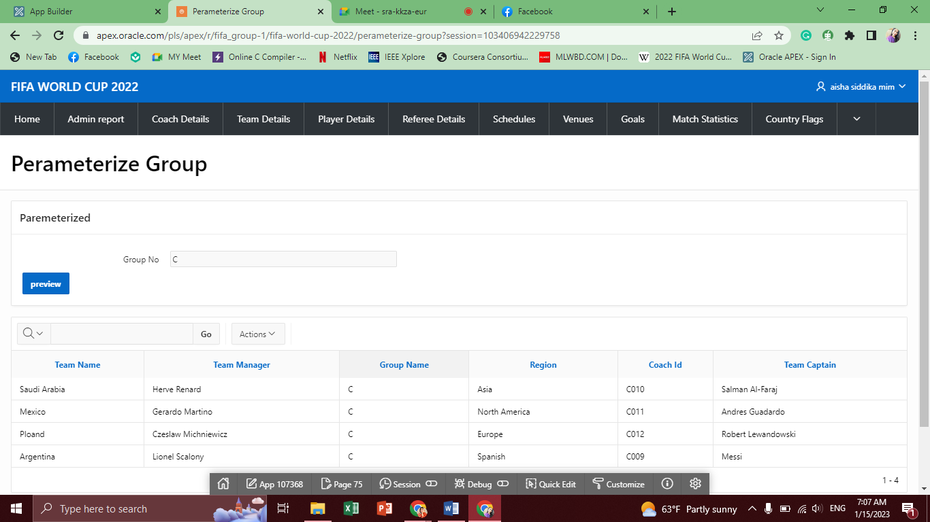

**15.3**

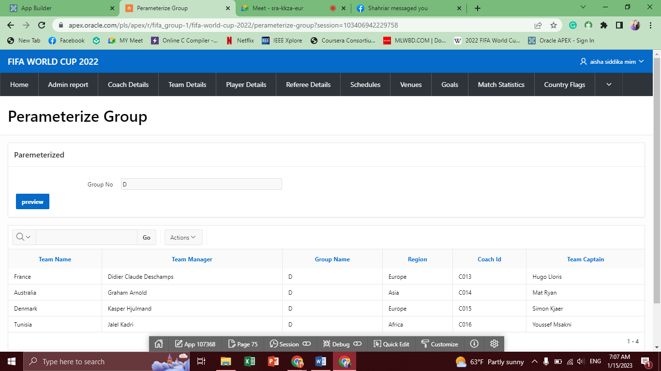

**15.4**

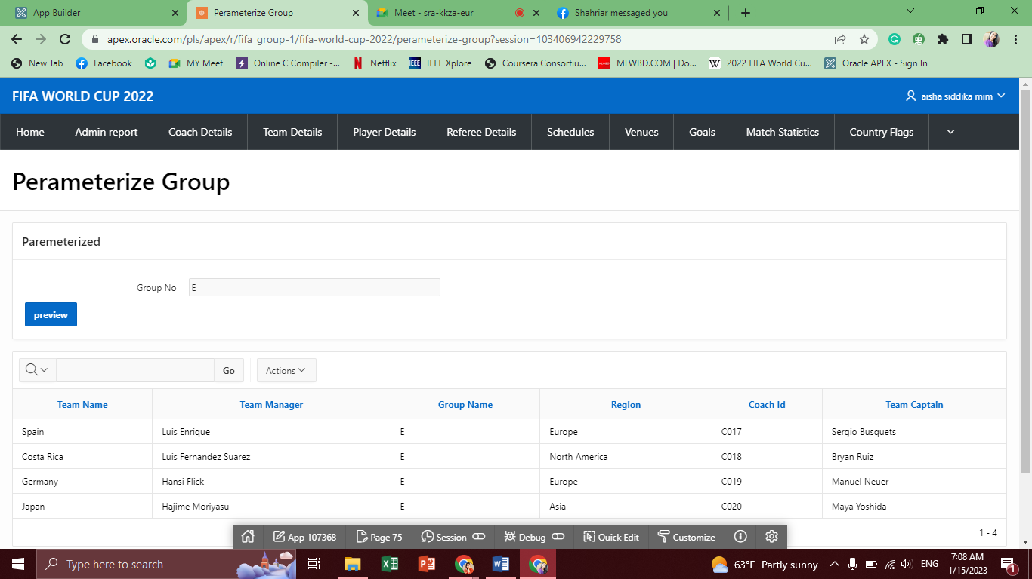

**15.5**

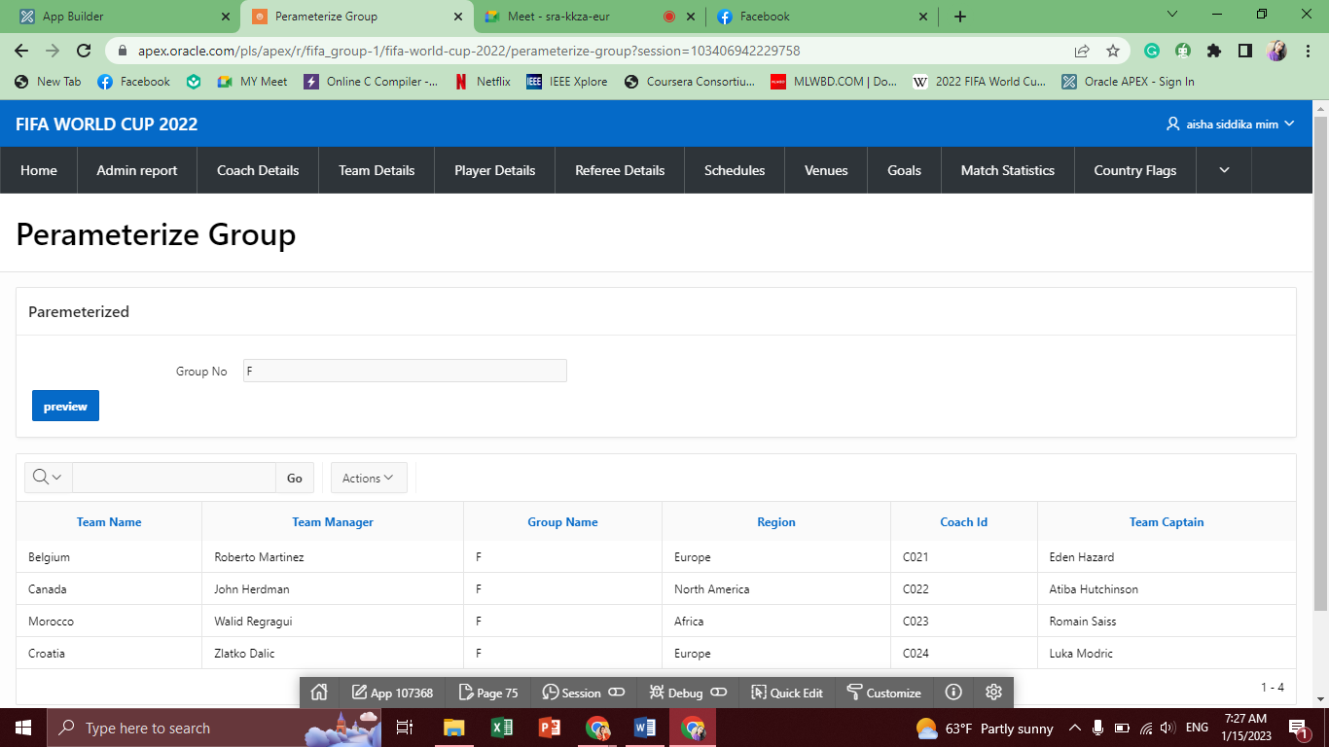

**15.6**

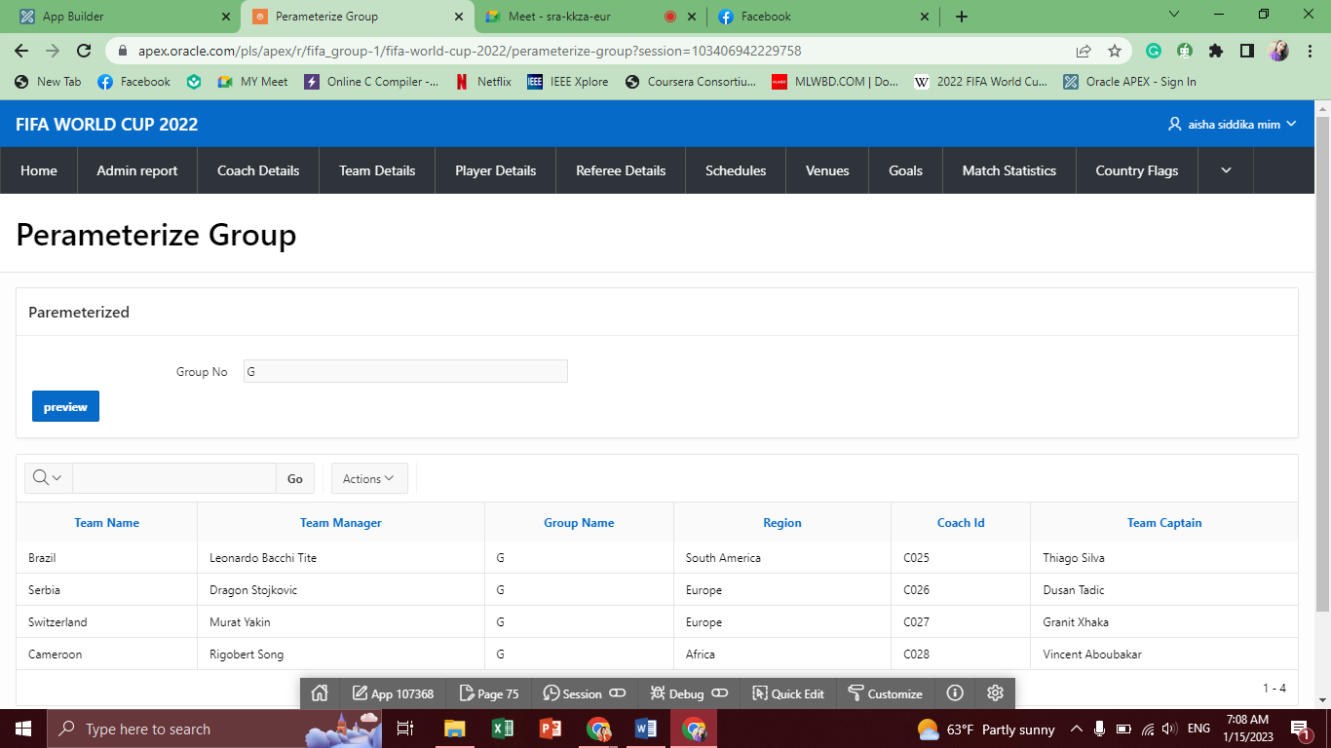

**15.7**

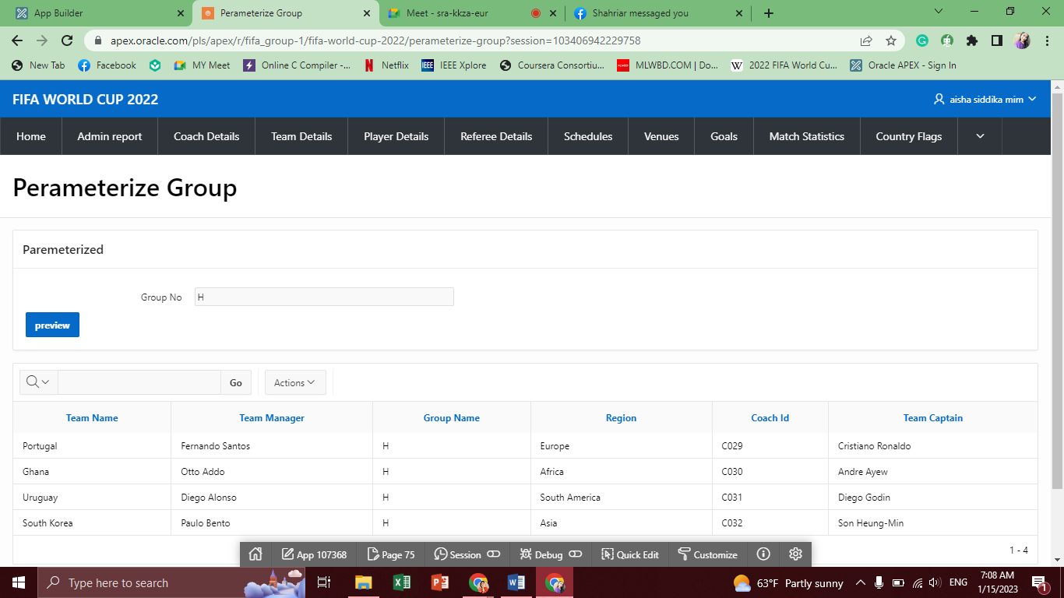

**15.8**

# Charts and Other Pages

|  |  |
| --- | --- |
| Page Number and Name | Chart description |
| write your page number and name here | write the description of the chart in a simple sentence such as this bar chart shows the number of students enrolled per semester at each year. |
| 30-Player Performance | Shows the total goals for each player through a bar chart |

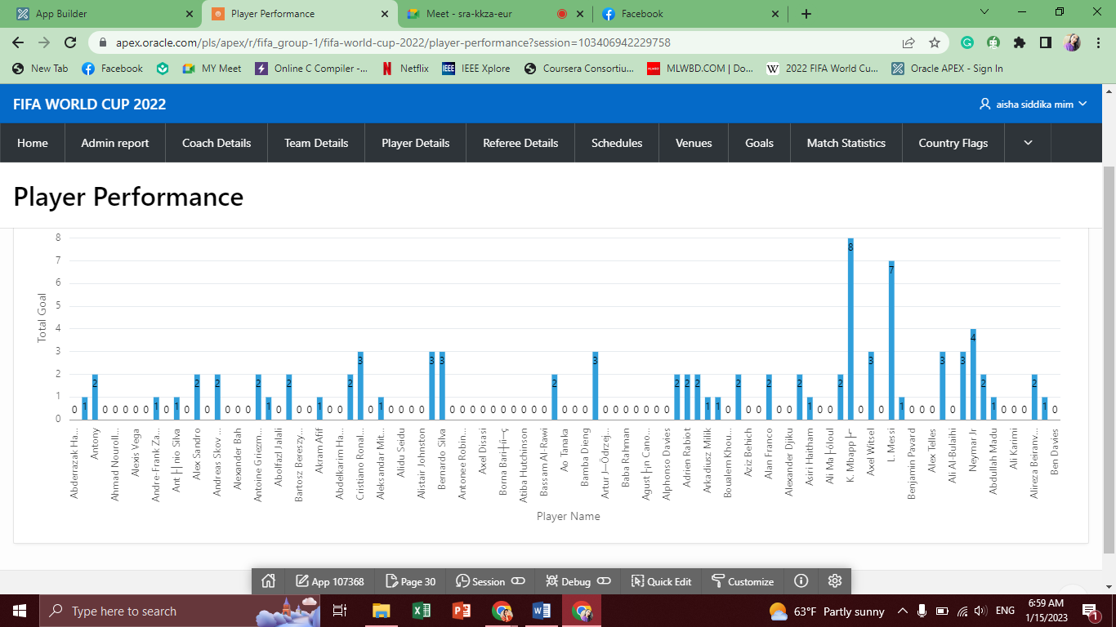

**16.1**

# Authorization and User Role Assignment

**User Role Assignment**

|  |  |  |
| --- | --- | --- |
| User name | Password | Role |
| Example: admin | Example: admin123 | Example: Administrator |
| Munem Shahriar | 2020-1-60-156 | Administrator |
| Aisha Siddika Mim | 2020-1-60-040 | Administrator |
| Tamanna E Jahan | 2020-1-60-151 | Administrator |
| Anik | 2019-3-60-051 | Administrator |
| Manager | Manager | Contributor |
| Guest | Guest | Reader |

**Page-wise Authorization Information**

|  |  |
| --- | --- |
| Page number and name | Authorization Level |
| Example: P1. Home | Reader |
| Example: P10000: Administration | Administrator |
| 10-Admin Form | Administrator |
| 02-Admin Report | Reader |
| 05-Coach Form | Administrator |
| 07-Player Form | Administrator |
| 09-Referee Form | Administrator |
| 10-Match Form | Administrator |
| 15-Schedule Form | Administrator |
| 17-Venue Form | Administrator |
| 19-Goals Form | Administrator |
| 21-Match Statistics Form | Administrator |
| 41- Image Form | Administrator |
| 48-Team Form | Administrator |
| 85-Result Form | Administrator |
| 02-Admin Report | Reader |
| 04-Coach Report | Reader |
| 06-Player Report | Reader |
| 08-Referee Report | Reader |
| 11-Match Report | Reader |
| 14-Schedules | Reader |
| 16-Venues | Reader |
| 18-Goals | Reader |
| 20-Match Statistics | Reader |
| 40-Country Flags | Reader |
| 47-Team Report | Reader |
| 84-Match Result | Reader |
| 31-Points | Reader |
| 30-Player Performance | Reader |
| 34-Master Details | Reader |
| 44-Golden Boot Nominees | Reader |
| 46-Team Wise Total Goal | Reader |
| 74-Group | Reader |
| 46-Highest Scorer | Reader |

# Concluding Remarks

Write briefly about your experience during the project development. Write your raw feelings without any fear. I want to hear it! Thank you and Good Luck.